Newspaper Advertisements


Above: The above advertisement was published in several Oklahoma City area newspapers, including but not limited to; The City Sentinel, The Bethany Tribune, Piedmont Surrey Gazette.

Below: The following advertisement was published in several Oklahoma City area newspapers, including but not limited to; The City Sentinel, The Bethany Tribune, Piedmont Surrey Gazette.


Below: This advertisement was published in several Pauls Valley area newspapers, including, but not limited to; Pauls Valley Democrat, Lindsay News, Ada Evening News, Sulphur Times Democrat, Garvin County News Star, Wynnewood Gazette, Davis News and ECU Journal.



Below: The following advertisement, with some variations, was published in several Oklahoma newspapers throughout the state; serving the areas and surrounding areas of Oklahoma City, Edmond, Midwest City, Shawnee, Norman, Pauls Valley, Ardmore, Chandler, Chickasha, Clinton, Elk City, Woodward and Yukon.

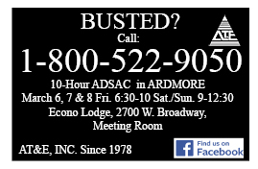

Below: The following four advertisements were published in The Gazette, serving the Oklahoma City Metro Area.





Below: The following two advertisements were published in Look at OKC, serving the Oklahoma City Metro Area.





Below: The following four advertisements were published in Edmond area newspapers, including, but not limited to; Edmond Sun, Guthrie Leader and University of Central Oklahoma’s: The Vista.

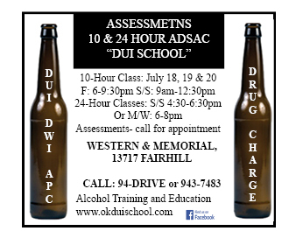

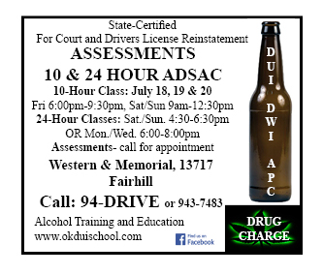





Below: The following advertisement will be published in The Bethany Tribune on March 25th, serving the Oklahoma City Metro Area.
